Course Name | ITD 2313 – Script Programming
Instructor | Rene Hurst
Student Name | Pete Fuentez
Due date | Sept 8, 2024 by 11:59 pm
Grade | Put grade earned here
Grading Comments | Put instructor comments here

Week 1 - Scripting Projects Assignment

Project # 1
Special Instructions:
This project does require you write a python program. Submit that python program as part of your submission zip file. Call the program Project1-YourLastName 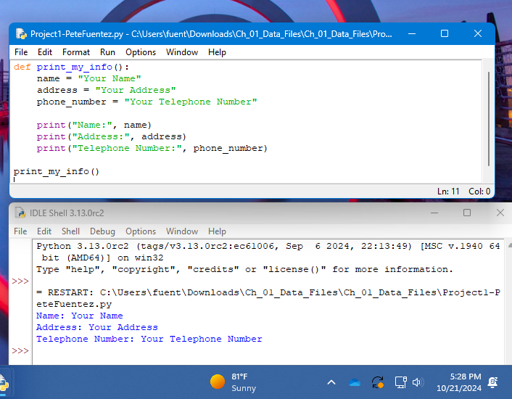

Project # 2
Special Instructions:
1. This project does require you write a python program. Submit that python program as part of your submission zip file. Call the program Project2-YourLastName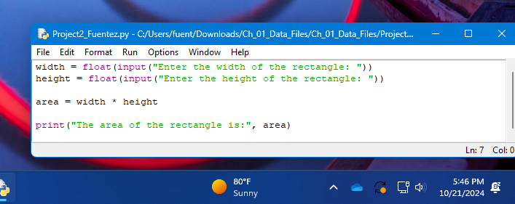

2. Specific Test data: You are to run this one 3 times also. Use the following Base and Height pairs for those three runs.
Run 1 - Length 11 Width 4
Run 2 - Length 8 Width 15
Run 3 - Length 8 Width 8
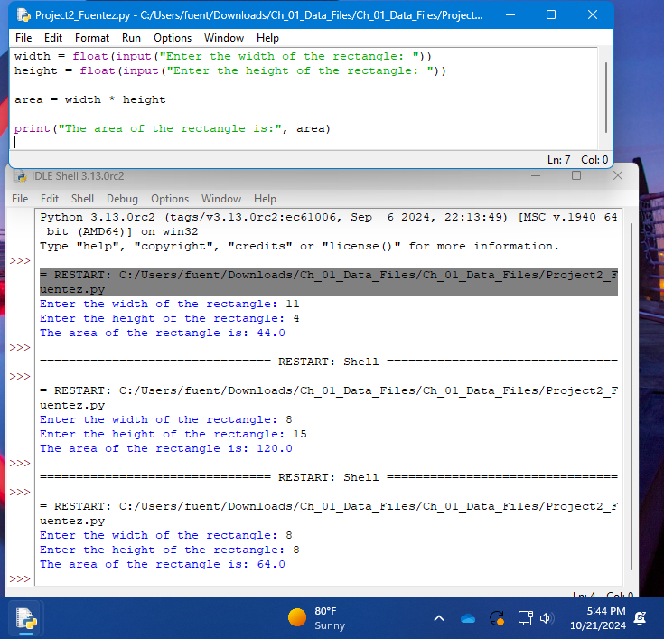

Project # 3
Special Instructions:
1. This project requires that you write a python program. Be Sure to include that file in the zip file when submitting the assignment. 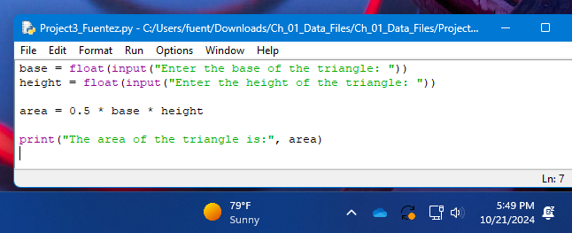
2. Specific Test data: You are to run this one 3 times also. Use the following Base and Height pairs for those three runs.
Run 1 - Base 6 Height 9
Run 2 - Base 4 Height 8
Run 3 - Base 9 Height 9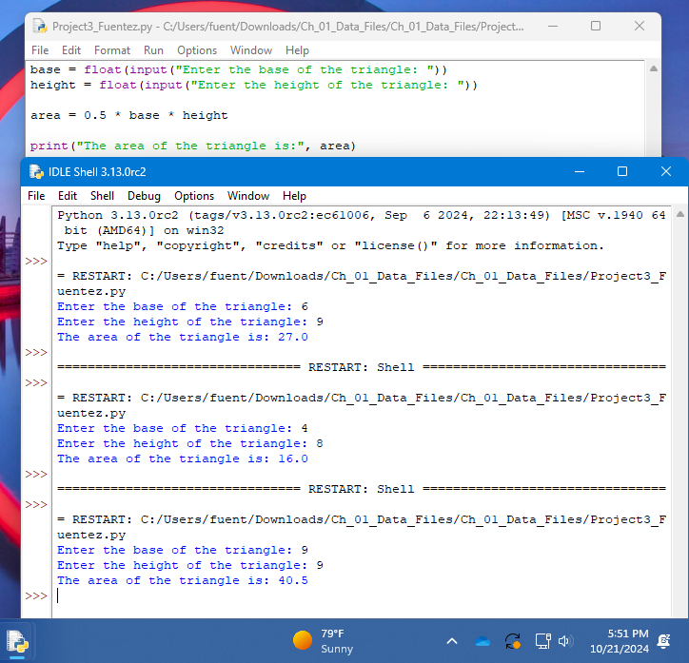

Project # 4
Special Instructions:
1. This project requires that you write a python program. Be sure to include that file in a zip file when submitting the assignment. 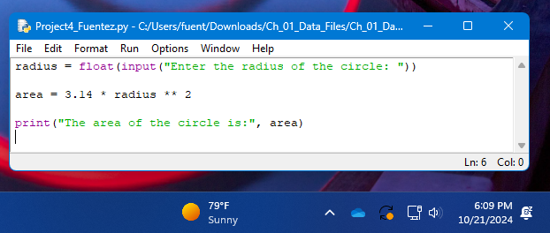

2. Specific Test data: You are to run this one 3 times also. Use the following Base and Height pairs for those three runs.
Run 1 - 7
Run 2 - 6.31
Run 3 - 14.96 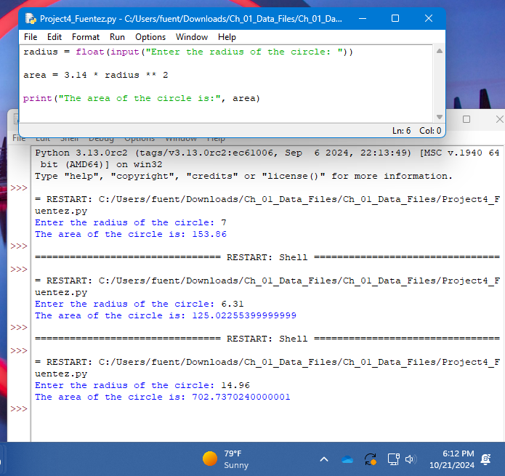

Project # 5
Special Instructions:
1. This project requires that you write a python program. Be sure to include that file in a zip file when submitting the assignment. 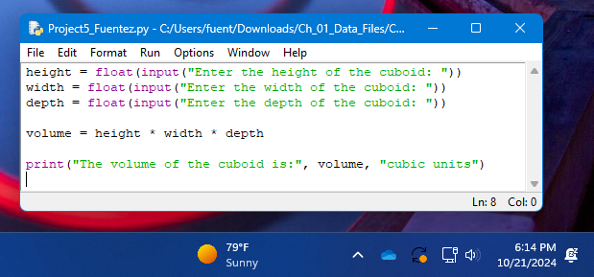

2. Specific Test data: You are to run this one 3 times also. Use the following Base and Height pairs for those three runs.

Run 1 - Height 7, Width 9, Depth 5
Run 2 - Height 4, Width 7, Depth 3
Run 3 - Height 6, Width 6, Depth 6 